INTERREG EUROPE
SCALE UP PROJECT
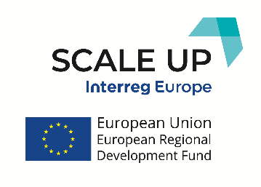

Attica Study Visit Online

- Date and link: 15 December 2020, 10:00 - 11:45 CET, online via https://www.conflix.net/live-streaming
- Moderators: George Kalpounias (RDFA) & Global Events Ltd

Housekeeping Rules to follow during the visit:
- Upon entry, please ensure that microphones and cameras are switched off to avoid noise interference.
- Questions will be taken via the Q&A section, but participants are encouraged to ask a question orally by raising their hand via the corresponding button, upon which the moderator will give them the floor at the appropriate time and unmute their microphone. This will happen at the end of each session.
- When asking a question, please go straight to the point so that we can ensure more interaction between the speaker and other participants.
- The conference will be recorded. However, the recording will not be published and will only be used as an internal video for reference purposes.
- Take freely picture shots during the meeting and share them through your social media accounts

Agenda:
… Say Hello!

9h45 Connection – Warm up – Social networking!
10h00 Welcome of participants, practical information and rules, video of promoting RDFA activities, Attica Business Environment - Context & SWOT analysis presentation
- Sotirios Nikolaropoulos (RDFA)
- George Kalpounias (RDFA)
- Kostas Karamarkos (RDFA Scale UP SG Coordinator)
- Vicky Karavaggeli (Project Consultant, Tsamis D.– Mantes K. OE)

RDFA Promotional video

10h30 BP1 – Competitiveness Toolbox (EPANEK)
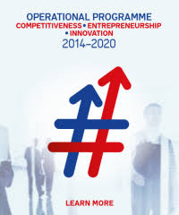
- Iro Anastasopoulou & Argiro Falagga, Project Managers, Managing Authority of Operational Programme Competitiveness, Entrepreneurship and Innovation 2014-2020
    - Hristina Vidali, Theodorodis SA, https://theodoridis.eu/ (program beneficiary)
    - Irini Lourou, TechniKal SA, https://www.technikal.gr/en (program beneficiary)
- Questions on BP1

11h00 BP2 – Innovation Center of Attica (ICAR)
- Petros Podaras, Director, ICAR, http://www.innovationattica.gr/en
- Nikolaos Karampekios, National Documentation Center (EKT), http://www.ekt.gr , (ICAR partner)
- Tbc, Attica ROP Managing Authority, (ICAR partner)
- Questions on BP2

11h30 Final Dialogue &
Closing remarks
- RDFA Representatives &
- Rafael Ataz Gómez, Head of the Department of European Programs at the Development Institute of the Region of Murcia
… Wave Goodbye!

